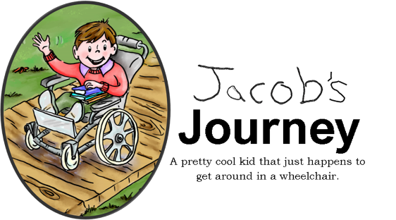
Social Media Consent/Release Form
For News Media, Promotional Materials, Comments, Written Articles, Research, Photographs, Readings, and/or Events for all things related to JacobsJourneybooks.com.

I hereby authorize Tracy Felix at Jacobsjourneybooks.com to use my photo and/or information related to my experiences with the website, and all involved including but not limited to, comments on merchandise, photos, personal experiences & memorials. I understand that this information may be used in publications, including, audiovisual presentations, promotional literature, advertising, community presentations, other public events, and readings. Tracy Felix at Jacobsjourneybooks.com will disclose to me or my legal representative (parent/guardian), where appropriate, the specific information and/or photo to be used prior to release in social media.
My consent is freely given as a service to Tracy Felix at Jacobsjourneybooks.com, without expecting payment. I release Tracy Felix at Jacobsjourneybooks.com of all liability which may arise from the use of such news and social media stories, promotional materials and comments, written articles, recordings, and photographs.

I give Tracy Felix at Jacobsjourneybooks.com permission to (Check all that apply):
- My complete name be used
- Only first name be used
- No name be used
- State of residence
- Use of photo
- Any comments you may want to share
I understand that I can revoke this release any time in writing (email) and that the use of any photographs or other information authorized by this release will immediately cease.
Please print or type:
Name of those involved (Parent or Guardian if person is under the age of 18):_________________
Address:_____________________________City, State, Zip:______________________________
Phone:______________________________Email:_____________________________________

Signature:__________________________________________Date:________________________

